**Unit Hydrograph Mini-Lab**

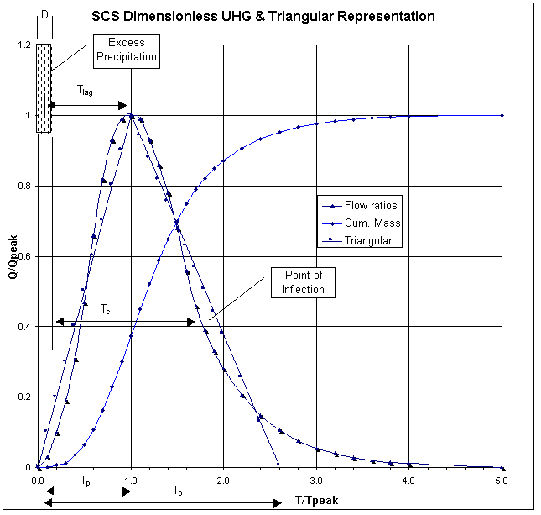

**Equations:**

|  |  |
| --- | --- |
| $$t_{L}= \frac{L^{0.8}{\left(S+1\right)}^{0.7}}{1900Y^{0.5}}$$ | *L* = hydraulic length (ft)  *Y* = slope (%)  *S* = potential max retention (inches) |
| $$t_{c}=\frac{5}{3}t_{L}$$ | *tc* = Time of concentration |
| $$t_{P}=0.67t_{c}$$ | *tP* = Time to peak |
| $$P_{e}=Q_{d}$$ | *Pe* = precipitation excess (inches, 1” in unit hydrograph case)  *Qd* = runoff depth (inches, 1” in unit hydrograph case) |
| $$Q_{P}= \frac{484 AQ_{d}}{t_{P}}$$ | Where 484 is the default peaking factor  Look up in table if want to change |
| $$S= \frac{1000}{CN}-10$$ | *CN* is the curve number, an empirical coefficient based on land cover and soil type |

Look up CN here: <https://en.wikipedia.org/wiki/Runoff_curve_number>